DRONE MASTER
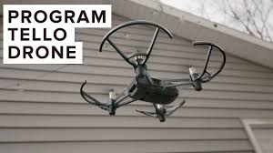
Contact:
Rajesh Raveendran TS398
Doctoral Researcher
rajesh.raveendran@oulu.fi

